
AN AWARD WINNER INTERNATIONAL ORGANIZATION
A_

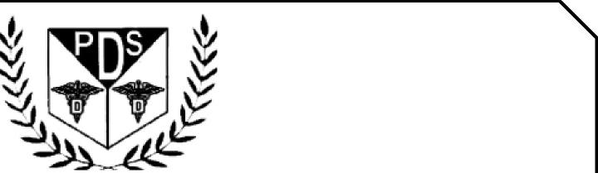
PROMOTING EXCELLENCE IN DENTAL EDUCATION
Over 7000 Members Strong
Presents
A Must attend seminar for you and your staff
PREVENTION OF CROSS CONTAMINATION IN DENTAL OFFICES
BY
DR RAMNEEK RAI DDS
ONLINE LIVE WEBINAR


On
March 8th , 2026 (Sunday) 8:00 am till 12:00 pm
(CA Board 4 hrs C.E. units)
at
(THIS INTERACTIVE WEBINAR IS CONSIDERED BY CA DENTAL BOARD AS LIVE COURSE)
(Please print in capital letters or attach your business card)
Name DR/RDH/RDA/DA Lic no
Circle one First Middle Initial Last
Address
City State Zip
Cell no ________________ Accept text message yes/no E-Mail________________________________________
ARE YOU A PDS MEMBER: YES/ NO

REGISTRATION FEE
Dentists Non-members | $50.00
Members | $40.00
Hygienist/R.D.A. Non-members | $40.00
Members | $35.00
FOR REGISTRATION
CALL TOLL FREE 1-866-422-5573 (1-866-4-CALL-PDS) OR 909-933-9076
TO REGISTER ONLINE VISIT US ON WWW PDSOCIETY. COM

Make check payable to

Dr. R. Salwan
President

PDS
124 EAST F STREET SUITE #8 ONTARIO, CA 91764
Dr. D.P. Singh Nagra
Chairman


Date & time

March 08,2026 8:00am- 12:00pm

Duration 4 hour

RAMNEEL RAI DDS
Director of Health and Safety
UCSF School of Dentistry
With more than 10 years of private practice experience and in serving as Director of Health and Safety at UCSF School of Dentistry, Dr. Rai has extensive knowledge and expertise in dental infection prevention. At UCSF, she teaches infection prevention, control, and safety practices, as well as supports predoctoral students and residents. She also provides health and safety oversight for 17 UCSF Dental Center clinics and led the center through the COVID-19 pandemic. Dr. Rai serves as Director on the Organization for Safety, Asepsis and Prevention (OSAP) Association Board and Secretary to the OSAP Board. She completed her dental education at Dasmesh Institute of Dental Sciences in India and is an alum of the International Dentist Program at UCSF

